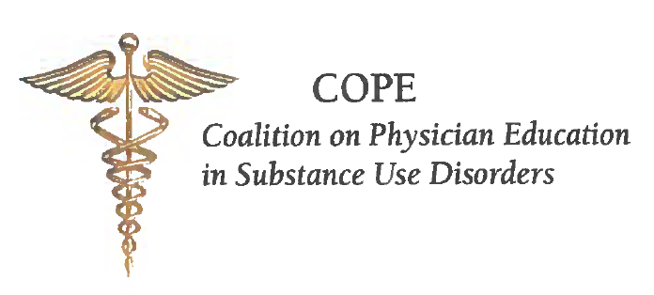
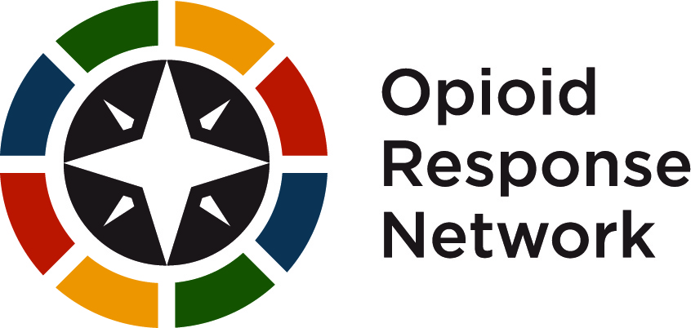

Curriculum Innovation Challenge:
Innovative Learning and Teaching About Substance Use/ Opioid Use Disorders 2.0
Application Form

Application Details
To apply, complete this Application Form, save as “Curriculum-Innovation- Challenge-Application-Form-yourschoolname”, and upload the completed Form at copenow.org, COPE Curriculum Innovation Challenge.

The full application should include a description of the proposed curriculum, of roughly 800-1000 words, outlining the purpose, relevance, and importance of the topic. COPE is interested in areas pertaining to the dimensions of clinical evaluation of substance use disorders and treatment planning that incorporate key ideas and issues in addiction medicine. You may wish to refer to the TAP 21 Competencies as a guide for what you might address.

The description should lay out the rationale for the proposed curriculum, why it is important, the basic intent of the project and how it will be incorporated into a specific core clerkship rotation. The application could also describe any sub-topics that the innovation will address. Prospective faculty mentors are encouraged to focus on a particular area, rather than attempting to be all-encompassing around a topic. The application should include a brief summary of the submitters’ previous experience with projects in curriculum design, if applicable.

COPE will conduct a review of all submissions. Prospective faculty mentors will receive notification within three weeks of submission regarding their application. Accepted proposals from medical school teams will participate in three asynchronous collaborative conferences that will guide them in all stages of the curriculum design process, including peer review and revision of curricula.

Applicant Information:
Faculty Mentor Name:
Title (Clerkship Director for <Name of> Core Rotation or other equivalent):
Medical School:
Mailing Address:
Email Address:
Telephone Number:
Twitter handle:

(Complete if Medical Student(s) have been identified and duplicate this section as needed
or a statement of commitment to recruit one or more medical students to work on the project below)

Medical Student Applicant Team Member Name:
Medical School:
Year of graduation:
Mailing Address:
Email Address:
Telephone Number:
Twitter handle:

Statement of commitment to recruit one or more medical students to work on the project (if a student is not yet identified):

Summary of the proposed integration of addiction medicine into the school’s clerkship curriculum, including a description of the proposed curriculum, of roughly 800-1000 words, outlining the purpose, relevance, and importance of the topic including the commitment to integrate this addiction medicine topic into the clinical curriculum in a specific core clerkship experience.

Agreement to participate in three virtual Collaborative Conferences for a fall, winter, and spring session to be determined based on participant availability.

Signature of support from the appropriate Administrator (i.e. Regional Assistant Dean, Dean of Clinical Education, or Academic Affairs, etc.)

Selection Criteria:
Preference will be given to those applications that demonstrate a strong commitment to the process. COPE is particularly interested in integrating addiction medicine into areas of clinical medicine where this topic is not usually addressed.

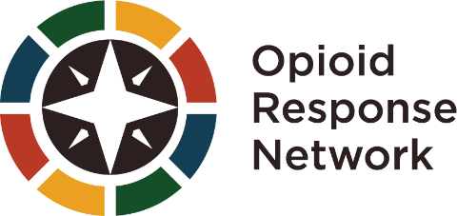
Funding for this initiative was made possible (in part) by grant no. 1H79TI083343 from SAMHSA. The views expressed in written conference materials or publications and by speakers and moderators do not necessarily reflect the official policies of the Department of Health and Human Services; nor does mention of trade names, commercial practices,
or organizations imply endorsement by the U.S. Government.

2022 Call for Submissions Rubric
Category | (4) Exceeds Expectations | (3) Meets Expectations | (2) Approaching Expectations | (1) Does Not Meet Expectations
Clarity of the proposed curriculum description | The proposal, including the title and the description, is very well-written. It aligns clearly with the content and purpose of the proposal. Provides a compelling problem or topic pertinent to the discipline/field. | The proposal, including the title and the description, is clearly written. Provides a problem or topic applicable to the discipline/field. | The proposal, including the title and the description, is clearly written. May need additional editing. Discusses a problem or topic within the discipline/field. | The way in which the proposal, including the title and the description, is not adequately written. Discusses a problem or topic outside of the discipline/field.
Content/purpose of the identified need for the innovation | The content and purpose are cutting edge and innovative. Content and purpose describe specific knowledge and skills that advance teaching and learning in addiction medicine. | The content and purpose are current and important. Content and purpose describe knowledge and skills that support teaching and learning in addiction medicine. | The content and purpose are somewhat current and/or important. Content and purpose partially describe knowledge and skills and/or improvement in teaching and learning in addiction medicine. | The content and purpose are not current. Content does not describe specific knowledge and skills. Teaching and learning are not advanced.
Clarity of commitment to implement | Commitment to implementation is clear and strongly supports the proposal. | Commitment to implementation is somewhat clear and supports the proposal. | Commitment to implementation are uneven and only somewhat support the proposal. | Commitment to implementation is not clear and does not support the proposal.
Category | (4) Exceeds Expectations | (3) Meets Expectations | (2) Approaching Expectations | (1) Does Not Meet Expectations
Feasibility and potential impact of the innovation (institution, specialty, field) | The proposal is highly relevant and significant to the field. | The proposal is relevant to the field. | The proposal is somewhat relevant to the field. | The proposal lacks importance or relevance to the field.
Appropriateness of the innovation for medical students in core clerkships | Clear intention to ensure medical students’ understanding of the elements of clinical evaluation and treatment planning. | Intention to ensure medical students’ understanding of the elements of clinical evaluation and treatment planning. | Weak intention to ensure medical students’ understanding of the elements of clinical evaluation and treatment planning. | Intention does not support medical students’ understanding of the elements of clinical evaluation and treatment planning.

